**PROPOSED TITLE**

**CLOUD-HOSTED IP-PBX PHONE SYSTEMS USING ASTERISK AND ORACLE CLOUD**

**FIELD OF INVENTION**

This invention relates to the telecommunications system (VoIP) that utilizes a cloud-based (Oracle Cloud) infrastructure and open-source software Asterisk to provide reliable and scalable phone service to users.

The invention provides a cost-effective and flexible solution for businesses of all sizes to manage their phone systems in the cloud, eliminating the need for costly on-premises hardware and maintenance. The system can be easily configured and customized to meet the specific needs of each business and can be scaled up or down as needed to accommodate growth or changes in call volume.

Overall, the invention has a wide range of applications in the telecommunications industry, offering businesses and organizations of all types and sizes a reliable, scalable, and cost-effective solution for managing their phone systems in the cloud. Overall, this is preferable for any organization that needs a flexible, reliable, and scalable phone system.

**BACKGROUND**

A brief study of previous scientific journals related to the implementation of phone communication systems using Voice over Internet Protocol (VoIP), and asterisk server shows that the system was implemented using raspberry pi or a virtual machine as a server that required lots of hardware like Raspberry pies which comes with limited resources/computational power and wires to connect the phones which can be very complex to setup even for a professional also with the hardware there is always hardware cost associated with it.

The previous version of VoIP implementation using asterisk has very low scalability, is costly to implement, and has very high maintenance.

Above stated problems can be fixed through this invention in which hardware will be replaced by Oracle Cloud which is free for a lifetime. This will give many advantages to the overall phone system.

**OBJECTIVES**

* The main objective of this invention is to reduce the installation, hardware, and communication costs of the traditional phone for an organization.
* Another objective of the present invention is to make the system more scalable without increasing any cost except for physical phones.
* A further objective of this invention isto add a MySQL database that will store all the call logs for future purposes that can be accessed by the users and admin.
* Still yet another objective of the present invention is to replace all the hardware except physical phones with the cloud.

**MODEL/FLOWCHART**

The proposed system uses a cloud service provider to route all the telephone calls through the cloud server. The system uses Oracle Cloud as a cloud service provider. The system uses an Ubuntu server machine to install the Asterisk server. The calls are routed from this Asterisk server.

To set up the system, an instance of Ubuntu machine is created which is used to install and configure the Asterisk server. Asterisk is an open-source software that provides a complete PBX system for VoIP (Voice over Internet Protocol) applications. By using Asterisk, the system can handle the essential features of a telephony system. Given below is the architecture of the system.

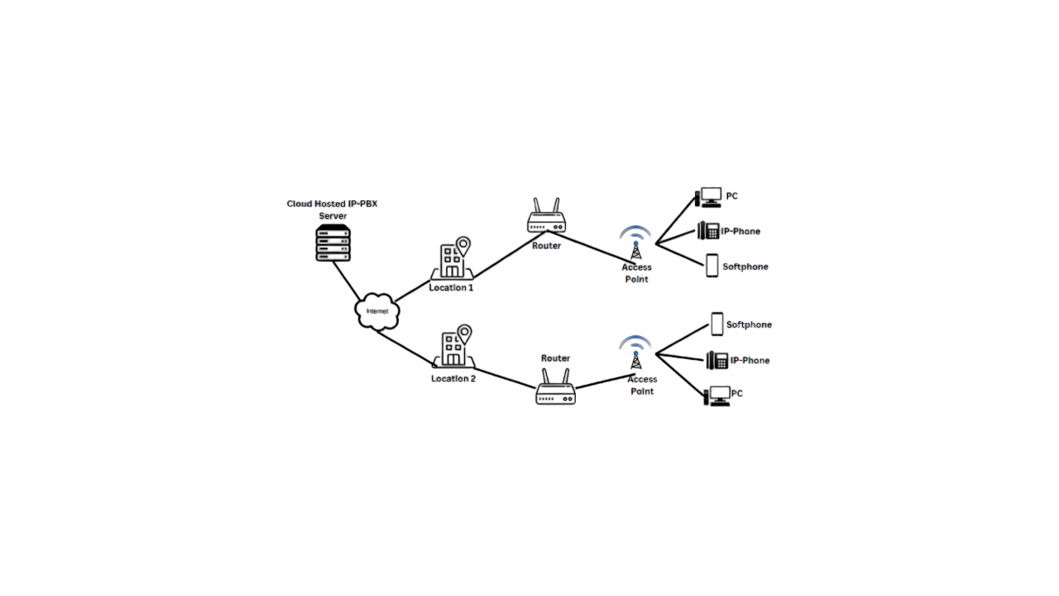

Figure 1 Architecture of the system

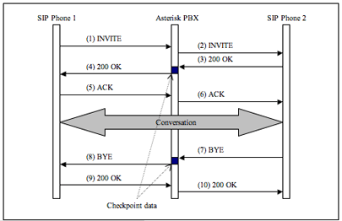

Figure 2 Request and Response of calls

**

Figure 3 Incoming call flow Figure 4 Outgoing call flow

**CLAIMS**

Our innovative idea is to provide an internal communication phone system for organizations in the cloud, eliminating the need for external hardware equipment and providing easy access from anywhere. We utilize the Oracle Cloud service as our cloud service provider due to their lifetime free server offering of Ampere A1 CPU. Although these resources are limited, they are more than sufficient for small organizations looking to set up a phone system on the cloud.

**TECHNOLOGY USED**

**• VoIP or Softphone**

A VoIP phone is a hardware - or software-based telephone designed to use voice over Internet Protocol (VoIP) technology to send and receive phone calls over an IP network.

**• Asterisk Server**

Asterisk is an open-source framework for building communications applications.

Asterisk turns an ordinary computer into a communications server. Asterisk powers IP PBX systems, VoIP gateways, conference servers, and other custom solutions.

**• Cloud-Based Ubuntu Server**

Ubuntu Server is a server operating system, developed by Canonical and open-source programmers around the world, that works with nearly any hardware or virtualization platform.

**• SIP**

SIP stands for Session Initiation Protocol. The Session Initiation Protocol (SIP) is a signalling protocol used for initiating, maintaining, and terminating communication sessions that include voice, video, and messaging applications.

• **MySQL Database**

MySQL database is used to store the call details of all the connected extensions through the cloud server.

**ABSTRACT**

This project aims the development of a cloud-hosted phone system using the open-source project Asterisk and the cloud service provider Oracle Cloud. The project discusses the design, implementation, and testing of the system, as well as the benefits and challenges of using a cloud-hosted approach for phone systems.

This study also evaluates the system's reliability, scalability, and cost-effectiveness, highlighting its potential as a viable alternative to traditional on-premises phone systems. The research concludes that the cloud-hosted phone system using Asterisk and Oracle Cloud can provide a flexible, efficient, and cost-effective communication solution for businesses of all sizes.

**END USERS**

The end-users of a cloud-hosted phone system using an Asterisk server for internal communication would be the employees of the organization that has implemented the system. These employees would use the system to communicate with each other within the organization using features such as voice calls, video calls, instant messaging, and conferencing.

The invention can be used by government agencies, Hospitals, educational institutions, Hotels, and Small and medium-sized businesses to manage their phone systems in the cloud, offering a cost-effective and flexible alternative to traditional on-premises phone systems.

With a cloud-hosted phone system using an Asterisk server, employees can access the system from a range of devices, including desk phones, softphones (software-based phone clients), and mobile phones. This allows for greater flexibility in communication and can help to increase productivity and collaboration within the organization.

**ADVANTAGES**

* Calling service is free the only cost associated with this system is the cost of physical phones.
* Only requires an Internet connection for communication.
* It does not require a lot of hardware (only physical phones).
* Work with different devices like Android, Windows, Linux, and IP-based phones.
* It easily supports remote work.
* It keeps logs into the cloud server.
* New services and features can be added easily.
* Flexibility with the reallocation of the phone anytime as it is wireless.

**CONCLUSION**

This research project aimed to create a communication System, to enhance voice communication inside any organization. The previous system uses Raspberry Pi devices in different research papers to implement the Asterisk PBX system. That system causes a sort of delay Because the system Used the Raspberry Pi which comes with limited computing Resources.

But now we are replacing the Raspberry Pi device with the Cloud Server because we have a suitable number of resources available in the cloud.

The research project was particularly challenging, especially because the system is Linux based. The result was satisfying since the main objectives were realized.

**AUTHORS**

|  |
| --- |
| **Ms. Akanksha**  Assistant Professor  Department of Computer Science  (KIET Group of Institutions)  Email Id: [akanksha.cs@kiet.edu](mailto:akanksha.cs@kiet.edu) |
| **Rupesh Kumar**  Student  Department of Computer Science  (KIET Group of Institutions)  Email Id: [rupesh.2024cs1202@kiet.edu](mailto:rupesh.2024cs1202@kiet.edu)  picture |
| **Yash Surya**  Student  Department of Computer Science  (KIET Group of Institutions)  Email Id: [yash.2024cs1009@kiet.edu](mailto:yash.2024cs1009@kiet.edu)  picture |
| **Vinay Kumar**  Student  Department of Computer Science  (KIET Group of Institutions)  Email Id: [vinay.2024cs1183@kiet.edu](mailto:vinay.2024cs1183@kiet.edu)  picture |